# Design Patterns and Refactoring

## Phase-1

**Group Members:**

Muhammad Umar Hayat 16030011

Muhammad Feroze Waris 16030056

Muhammad Qasim Hunain 16030012

Hassaan Fayyaz 16030009

# Class Diagram

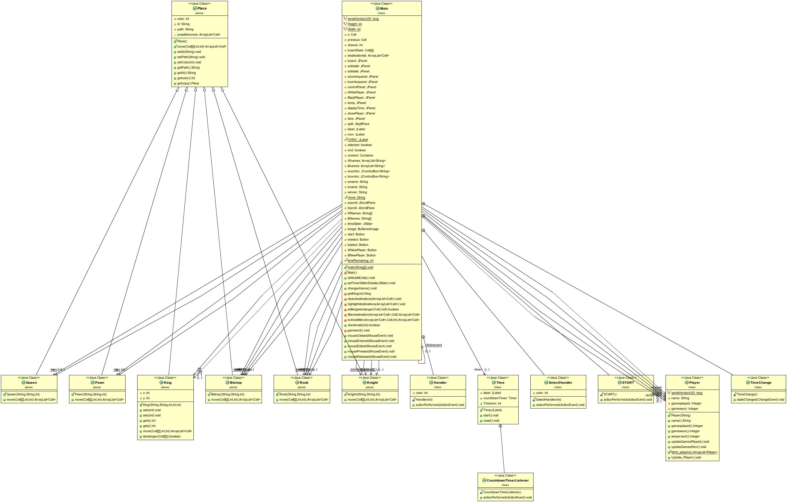

# Code Smells

1.

Code Smell: Long Methods

Class: Main.java

Method: defineAllCells()

Re-factoring: Extract Method

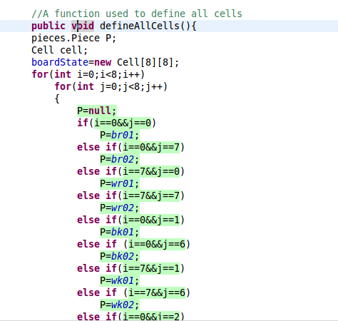

2.

Code Smell: Long Methods

Class: Main.java

Re-factoring: Extract Method

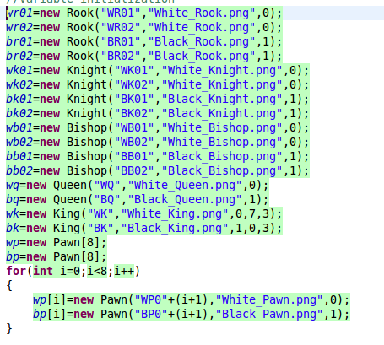

3.

Code smell: Long Method

Class: Main.java

Re-factoring: Extract Method

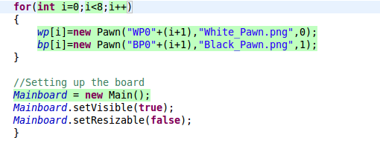

4.

Code smell: Long Method

Class: Player.java

Method: update_player

Re-factoring: Extract Method and Renaming

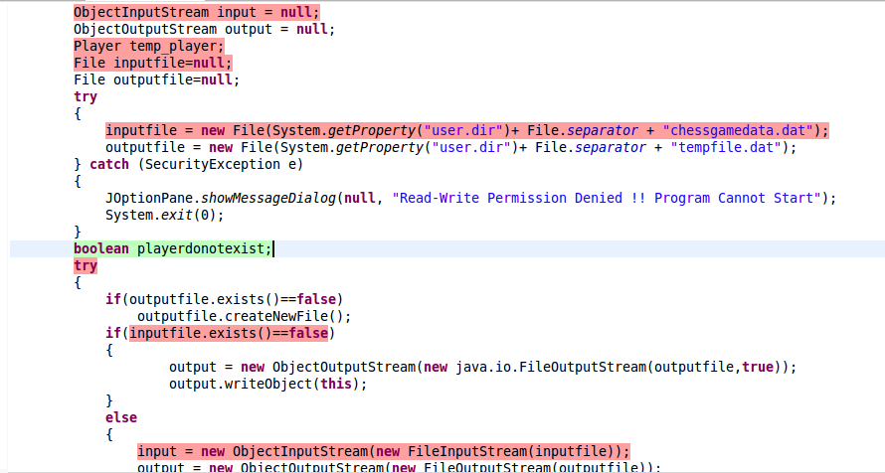

5.

Code Smell: Type Checking

Class: Main.java

Method: mouseClicked

Re-factoring: Replace Conditional with Polymorphism

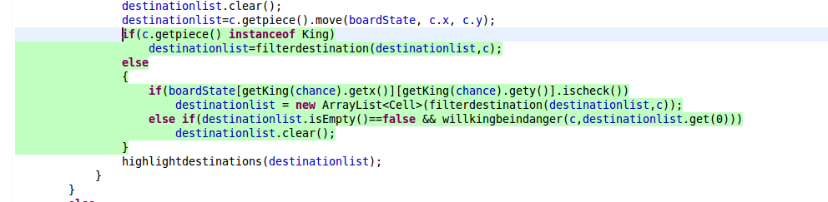

6.

Code Smell: Type Checking

Class: Cell.java

Method: removePiece

Re-factoring: Replace Conditional with polymorphism

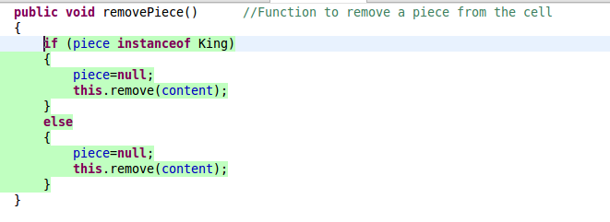

7.

Code Smell: God Class

Class: Main.java

Re-factoring: Extract Class

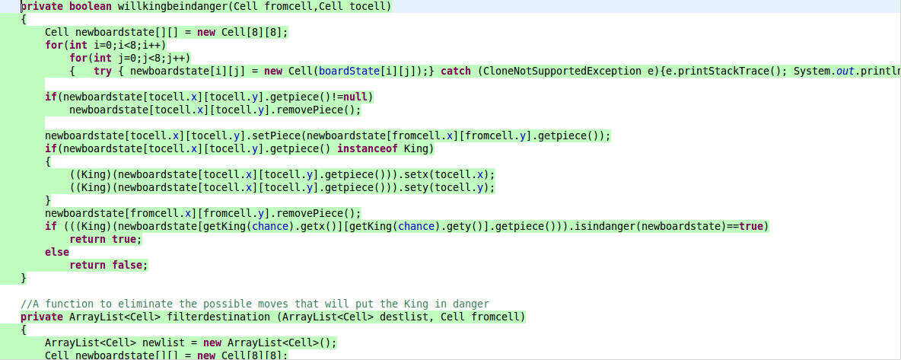

8.

Code Smell: Java naming convention violated

Class: Main.java

Re-factoring: Use meaningful names

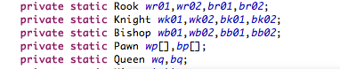

9.

Code Smell: Avoid using implementation types like 'ArrayList'

Class: Main.java

Re-factoring: Use the interface instead. i.e, List interface

../../../../../../../../../Users/Hassaan/Desktop/Screen%20Shot%2

10.

Code Smell: Some variables in code start with uppercase character.

Class: Main.java

Re-factoring: Variables should start with a lowercase character

../../../../../../../../../Users/Hassaan/Desktop/Screen%20Shot%2

11.

Code Smell: Action level scope is defined for the variables which are used locally in one function only.

Class: Main.java

Re-factoring: Perhaps 'wscroll' and 'bscroll' could be replaced by a local variable.

../../../../../../../../../Users/Hassaan/Desktop/Screen%20Shot%2

12.

Code Smell: Bad Programming Practice.

Class: Main.java

Re-factoring: Use a logger instead.

../../../../../../../../../Users/Hassaan/Desktop/Screen%20Shot%2

13.

Code Smell: Method Chaining.

Class: Main.java

Re-factoring:

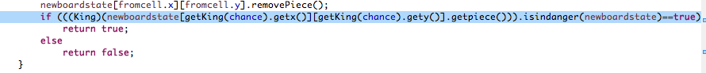

14.

Code Smell: Short variable names used

Class: King.java

Re-factoring: Use meaningful names

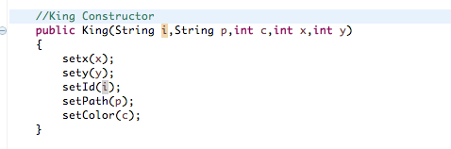

15.

Code Smell: Useless parentheses.

Class: King.java

Re-factoring: Do not use extra parenthesis.

../../../../../../../../../Users/Hassaan/Desktop/Screen%20Shot%2

16.

Code Smell: Unnecessary long comment.

Class: Time.java

Re-factoring: Do not use comments. Instead function or class name should be descriptive.

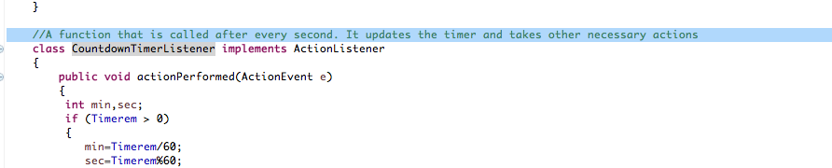

17.

Code Smell: if and for statements used without curly braces.

Class: Knight.java

Re-factoring: Avoid using if and for statements without curly braces

